Name: _____________________
Science Quiz – The Weather

Match
- Canada… |  | - Imaginary line that divides the earth in half
- Australia… |  | - You can tell what will happen before it happens
- Climate |  | - Drops of water
- Moisture |  | - …is in the Northern Hemisphere
- Temperature |  | - The earth spins on this
- Equator |  | - A pattern of weather in a large area over long periods of time
- Axis |  | - What is going on in the air at a certain place and time
- Weather |  | - How hot or cold it is
- Predictable |  | - …is in the Southern Hemisphere
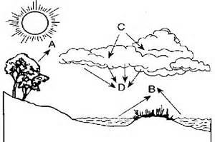
2. The Water Cycle
A: _______________________
B: _______________________
C: _______________________
D:________________________

Word Bank: evaporation, precipitation, condensation, transpiration

